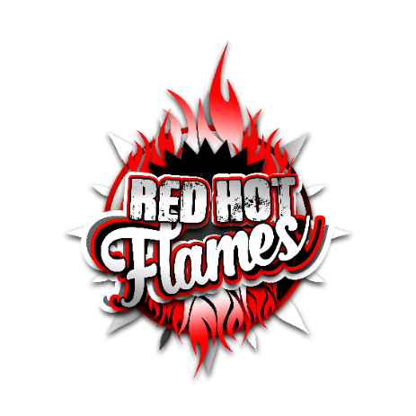

LIVE DOCUMENT POLICY

I fully accept by agreeing to Team App/Coacha terms and conditions all documents and policies for Red Hot Flames Dance Academy and Studio 96 Dance Academy CIC are Live Documents and do not require my signature.

I fully accept and agree to adhere by all rules and regulations as set out in each document/policy.

Updated: February 2021

